Researchers develop new 3D bioprinting technique for engineering joint cartilage
May 17, 2015 | By Simon
It’s no secret that of all of the advancements in additive manufacturing technologies, those that involve 3D bioprinting are among the most exciting to watch.
Among other reasons, 3D bioprinting may hold the answer to the future of organ replacements in the case that there may not be a donor available in a life or death situation. Among other projects that have been done, doctors may soon have the ability to not just 3D bioprint a replacement thyroid gland in a lab - but actually in an operating room next to a patient within minutes. Of course, scenarios like this exist on the extreme end of the spectrum, however the existing developments that are occurring today are moving at a rapid pace.
Among other recent developments, an international study published in the journal Nature Communications details a more effective use of biocompatible materials in repairing human tissues - particularly the restoration of joint cartilage.
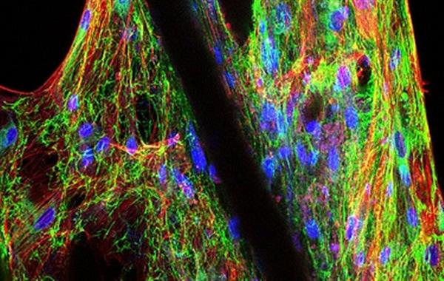
Because cartilage requires both mechanical strength and flexible properties, researchers at theTechnische Universität München (TUM) investigated a new 3D printing method that utilizes a combination of microfiber scaffolding and hydrogels. The resulting 3D bioprinted structures offered both stiffness and the elasticity that was similar to existing human-produced knee-joint cartilage. The researchers believe that this unique biofabrication method has the ability to support the growth and cross-linking of human cartilage cells and can benefit other areas of soft-tissue engineering researcher including organ tissue engineering and breast reconstruction.
To create their sample structures, the researchers used a relatively new additive manufacturing technique called melt electrospinning writing.
In melt electrospinning writing, a material “collector” moves at a sufficient speed while melted material fibers are deposited layer by layer before cooling off and establishing the foundation for subsequent layers - ultimately leading up to a three-dimensional structure. In the case of this experiment, the method helped provide room for cell growth while also retaining the desired amount of mechanical stiffness. Ultimately, the final structure allows for natural healing and helps promote the growth of new tissue.
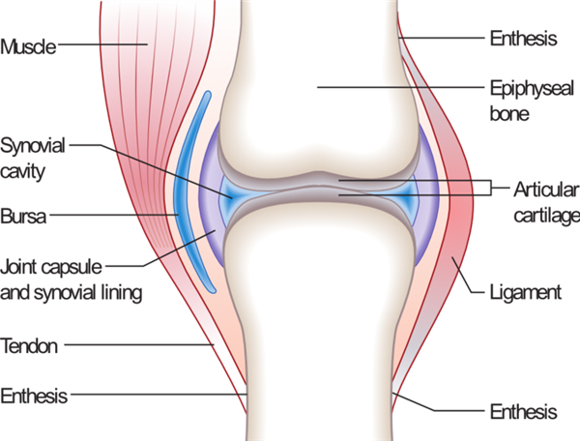

"(Melt electrospinning writing) allows us to more closely imitate nature's way of building joint cartilage," said Prof. Dietmar W. Hutmacher, one of the lead authors, "which means reinforcing a soft gel – proteoglycans or, in our case, a biocompatible hydrogel – with a network of very thin fibers."
Working alongside researchers from Australia, Germany, the Netherlands, and the UK, Hutmacher and the other researchers involved with the project are calling the evidence of their findings a “breakthrough” that will have a variety of potential applications.
"The new approach looks promising not only for joint repair, but also for uses such as breast reconstruction following a post-tumor mastectomy or heart tissue engineering," added Hutmacher.
"We need to implant the scaffolding under the muscle, and fiber-reinforced hydrogel could prove critical in regenerating large volumes of breast tissue, as well as the biomechanically highly loaded heart valves."
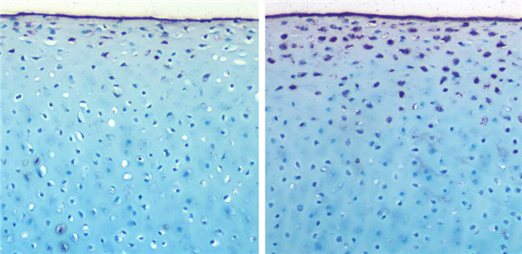
Prof. Hutmacher - along with his collaborators including Prof. Arndt Schilling, PD. Dr. Jan-Thorsten Schantz, and Dr. Elizabeth Balmayor from TUM, and Prof. Stefan Jockenhövel and Dr. Petula Mela of RWTH Aachen - have also announced that they plan on shifting their focus to breast tissue engineering and engineering heart valve tissue for the next phase of their studies.

